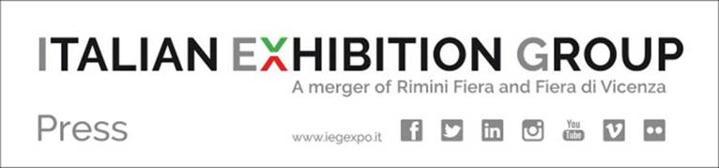

CORPORATE SOCIAL RESPONSIBILITY: AN IMPORTANT ACKNOWLEDGEMENT FOR IEG
FROM H.E. AMBASSADOR AL-NASSER (UN) AT RIMINI’S MEETING

Rimini, 22nd August 2017 – Since 1980 Rimini expo centre has hosted the Meeting for Friendship among Peoples and the 2017 edition is the “first” for Italian Exhibition Group, the new expo player founded on 1st November 2016 with the merger between Rimini Fiera and Fiera di Vicenza.

IEG is rightly proud to provide a stage that every year features sincere democratic discussion on man’s future, with the contribution of authoritative key players which, to use the words of the organizers “proposes experiences that have at their heart the desire to ‘build together’ to face today’s challenges with realism and courage.”

IEG’s role on the international economic scenario in favour of corporate social responsibility achieved a further important acknowledgement at the opening if the 38th edition of Rimini’s Meeting.

Quoting a phrase from Goethe’s Faust, “All that you have, bequeathed you by your father, earn it in order to possess it”, which inspires the proceedings at this edition of the Meeting, H.E. Ambassador Nassir Abdulaziz Al-Nasser, representing the Secretary General of the United Nations, emphasized the importance of working on nourishing the heritage based on the joy of life and happiness for Humanity and future generations.

Principles that inspired and drove the merger between the Rimini and Vicenza expo centres. Not only to construct an innovative international expo hub, but also and above all to highlight and acknowledge CSR (Corporate Social Responsibility), for which IEG is accredited via the CIBJO (World Jewellery Confederation), and also since last January with ECOSOC, the United Nations Economic and Social Council.

Issues brought up by Ambassador Al-Nasser, who in a note mentioned how the merger that led to the foundation of IEG e year ago is coherent with the message of the meeting: “We will be earning the right to the legacy!”, he stressed.

Ambassador Al-Nasser then reminded how the agreement that led to the foundation of IEG is profoundly linked with cultural difference, education, science, communication, health, sport, wellness and sectorial tourism, the environment and the jewellery industry. And how all this can in turn promote social cohesion, cultural comprehension and healthy development based on the principles of sustainability. All this is line with the message contained in the passage from Faust: “All that you have, bequeathed you by your father, earn it in order to possess it”.

In the picture from the left: IEG Managing Director Corrado Facco, IEG Executive Vice President Matteo Marzotto, Ambassador Nassir Abdulaziz Al-Nasser and IEG President, Lorenzo Cagnoni at Rimini’s Meeting.

ITALIAN EXHIBITION GROUP SPA: FOCUS ON
Italian Exhibition Group SpA, the Company generated by a merger between Rimini Fiera and Fiera di Vicenza, is led by President Lorenzo Cagnoni, together with Executive Vice President Matteo Marzotto and Managing Director Corrado Facco. IEG, which closed 2016 with a consolidated pro-forma turnover of Euro 124.8 million, a pro-forma EBITDA of Euro 21.9 million and a consolidated net result of Euro 6.6 million, is Italy's first player in terms of overall volume with 59 products in its portfolio (relating to Food & Beverage, Green, Technology, Entertainment, Tourism, Transport, Wellness, Jewellery and Fashion, Lifestyle & Innovation). It also holds first place in terms of gross operating revenue and boasts a total 216 events and congresses and 216 events and congresses. The Company's priority asset is to favour internationalization in segments representing Beautiful and Well Done around the world, starting from its already solid presences in the United Arab Emirates, where it has an on-going joint venture, and in the USA, China, India and South America. Furthermore, IEG is also the Italian leader in the convention and congress segment. In 2016, IEG events at its exhibition and congress sites in Rimini and Vicenza totalled 14,593 exhibitors and almost 2.5 million visitors.

